Strand: Visual

Grades: 5-6-7-8

Content: 45 minute broadcast + hands-on activity

Beading with Randi

Overview

Students will be led through the process of moss bag beadwork and design. It will incorporate a history to the art form including its significance and importance to Indigenous identity. Beadwork has the ability to connect and educate people to Indigenous history and experience and by weaving together deeper connections to understanding, Indigenous cultures emerge.

Artist Bio
Hello there, my full name is Randi Lynn Nanemahoo-Candline. I originate from the Bigstone Cree Nation in Northern Alberta. I am 31 years old and I currently work at Wanuskewin Heritage Park. I also teach powwow dancing and beading throughout the community. I moved out to Saskatoon to obtain my Indian Social Work degree, which I had completed in 2014. My Indigenous culture teachings and practices have always played a huge part in my identity and have helped me to overcome many obstacles. I am also a Jingle Dress dancer and I make all the beadwork for myself and my family, who also dance powwow. Thanks to my dancing, beading, and my education I have had many opportunities to present, teach, and travel throughout Canada and the United States. Dancing and beading plays a huge role in my life and are forms of self-care I greatly rely on. I enjoy sharing my experiences and cultural teachings/practices/arts with others.

Pre-Broadcast Preparation:
For this broadcast your students can stay in their desks. This program shows you the techniques and skills you need to do the Post-Broadcast Activity.

Post-Broadcast Activity Preparation:
- This project requires preparation and planning. Please read the materials list below. Students can work from their desks. It is recommended that you organize some volunteers to assist. Set up a hot glue station separate from students’ desk.

Diamond Shape Sequence Keychain Project

Materials List:
- Graph Paper
- Stiff Felt
- Cup Sequences (multiple colours)
- Silver/Clear Seed Beads
- Beading Needles (one per student)
- Nylon Beading Thread
- Key Chain Rings
- Pencil Crayons/Markers
- Scissors (sharp enough to cut material)
- Small Paper Plate (one per student, to allow them to put their beads and sequences on)
- Hot Glue Gun (with multiple hot glue sticks to refill)

Teachers To do:
- Cut graph paper into squares of 9x9 on the grid
- Cut stiff felt to same size as graph paper squares, each student will need two pieces of felt of the same size. One to attach graph paper to and one to back sewing with. (You can get stiff felt from Fabricland that has a heat and bond adhesive on it, allowing you to iron on the graph paper right on to the stiff felt, with out need of tape or glue).
- Cut nylon beading threat to two arms lengths, thread will be doubled and tied at the end.
- Thread beading needles for students before class, to reduce craft time (and frustration for students…optional)
- Display different colours of cup sequences so that students can easily obtain them.
- Give each student a pinch of silver/clear seed beads each on their paper plate.
- Cut out thin small strips of felt for each student. 4cm x 1.25cm
(These will be used as the keychain loops).

Saskatchewan Curriculum Outcomes:

Grade 5

CP5.8 Create art works using a variety of visual art concepts (e.g., positive space), forms (e.g., graphic design, photography), and media (e.g., mixed media, paint).
CR5.2 Respond critically and creatively to a variety of pop culture expressions.

Grade 6
P6.12 Demonstrate increased skills and problem-solving abilities in a variety of visual art media.

CH6.1 Investigate how personal, cultural, or regional identity may be reflected in arts expressions.

Grade 7

CR7.3 Examine and describe how arts expressions of various times and places reflect diverse experiences, values, and beliefs.

CR7.2 Investigate and identify ways that the arts can communicate a sense of place.

Grade 8

CR8.3 Investigate and identify how arts expressions can reflect diverse worldviews.

CP8.12. Solve visual art problems using a variety of processes and media.

Curriculum Aims & Goals

Creative/Productive:
Students will learn traditional and non-traditional techniques in the making of contemporary Indigenous craft.

Critical/Responsive:
Randi encourages the dialogue of the current uses of traditional craft. Artworks will reflect upon place.

Cultural/Historical:
Candline will discuss the importance and tradition of her craft.

Instructions for the Post Broadcast Activity

Student Instruction

1) Select 3 colours of sequences they like to use for their keychain. They will need....
1st Colour: 13 Sequences
2nd Colour: 8 Sequences
3rd Colour: 4 Sequences

2) Colour squares of graph paper with markers/crayons in accordance to the colours they have selected. First colour will be the outside row, Second colour will be the second row, Third Colour will be the 3rd row, and then the first colour will be used for the middle square.

3) Give each student take beading needle and thread. Have them pierce through bottom side of felt (opposite side of graph paper), in the centre of the first coloured square on top of diamond shape.

4) Have students pick up "first colour" sequence, followed with one silver bead. It is important to keep in mind that when using "cup sequences" you must pick it up, cup shape facing down, in order for it to be sewn down right side up.

5) Instruct students to push sequence and bead down to the bottom of their thread, and have them align the sequence within the square on the graph paper. Hold in place with finger.

6) Take beading needle and go through hole of sequence, by passing the bead. By doing so the bead will keep the sequence in place.

7) Have students take beading needle and come up, from the bottom side of felt, on the first square of the second row of diamond pattern. Repeat steps 4-6; keep sequence colours in accordance to colour of each square. Continue down diamond.

8) Upon completion of sewing sequences onto diamond pattern, you will want to tie off your thread. Make sure your thread is on the backside of the felt. Cut beading needle off of thread right at the tip of the needle. You will be left with two pieces of thread that you can tie 3-4 multiple knots with, to secure your sewing.

9) Rip off extra graph paper that may be sticking out beyond diamond sequence pattern. This will not wreck your sewing or affect it anyway.

10) Cut out completed sequence pattern, leaving a 0.5 cm border around sewing. If you cut to close to sequences, you risk cutting the thread and wrecking your project.

11) Have students take their thin strip of felt and fold it in half. Take hot glue gun and glue the folded in half strip to top of diamond pattern. Leave open loop at top to allow room to insert key chain ring.

12) Have students apply hot glue to the backside of their sewing project and quickly place on top of second piece of felt. Once dried, which should only take a few moments, have them cut off the excess felt from the backing piece, using the original diamond sequence shape to guide them.

13) Insert key chain ring through loop. You are now finished your project.

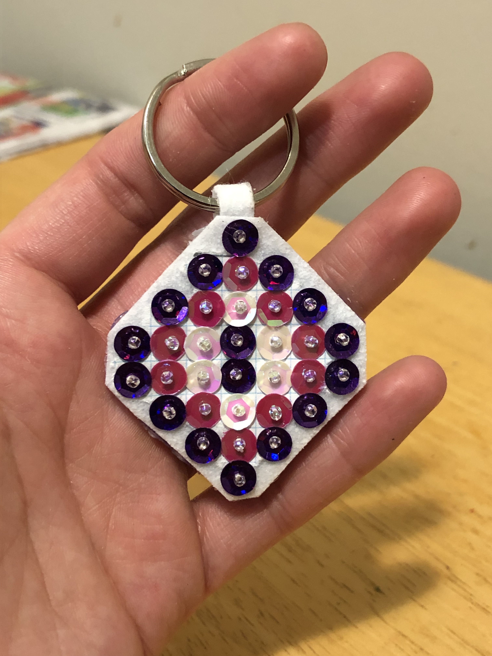
Upon completion you can challenge yourself or your students try to create bigger projects in various shapes and colours.

The possibilities are endless.

